 | - To perform shell scripting (Part – II)

Name of Student | Hardik Prajapati | Roll No. | 9152
Sign here to indicate that you have read all relevant material provided /available on Moodle while performing and writing this experiment |  | Sign:

Late Submission Details (if any)
Reason(s) of late submission | Date of practical performance | Date of practical submission

References used
1 | Name and author of reference book(s) with page nos.
2 | Name and roll nos. of the peers whose help you have taken (if any)

Rubrics for assessment of Experiment:
Indicator | Poor | Average | Good
Timeliness  Maintains Experiment deadline (3) | Experiment not done (0) | One or More than One week late (1-2) | Maintains deadline (3)
Completeness and neatness  Complete all parts of Experiment (3) | N/A | < 80% complete (1-2) | 100% complete (3)
Originality  Extent of plagiarism (2) | Copied it from someone else (0) | At least try to implement but could not succeed (1) | Implemented (2)
Knowledge  In depth knowledge of the Experiment (2) | Unable to answer any questions (0) | Unable to answer few questions (1) | Able to answer all questions (2)

Assessment Marks:
Timeliness
Completeness and neatness
Originality
Knowledge
Total

Signature of Teacher with date

1. | Course, Subject & Experiment Details

Course & Branch | T.E. (ECS) | Estimated Time | 02 Hours Per Week
Current Semester | Semester VI | Subject Name | Linux Server Administration
Chapter No. & Unit | 5.1 | Chapter Title | Bash Shell Scripting
Experiment Type | Software Performance | Subject Code | ECL 604

2. | Aim & Objective of Experiment
- To write programs using shell scripting
3. | Expected Outcome of Experiment
- To understand shell scripting
4. | Brief Description of the experiment

- Write a shell script program to display list of user currently logged in
Program:
lslogins

Screenshot:
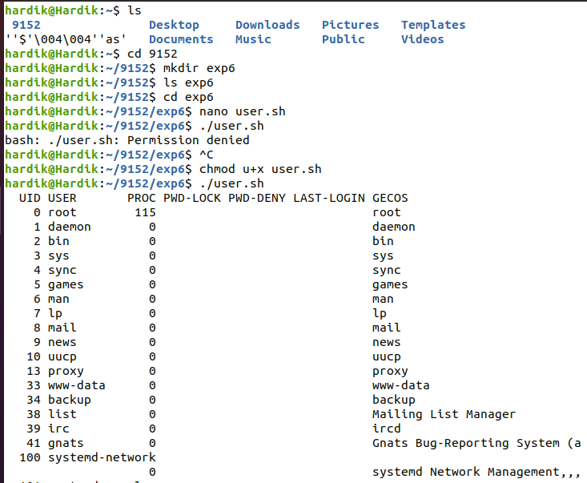

- Write a shell script program to display “HELLO WORLD”.
Program:
echo “Hello World”
Screenshot:
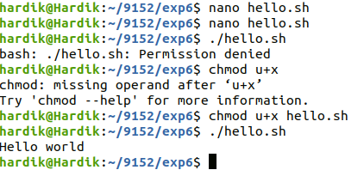

- Write a shell script Program to implement calculator
Program:
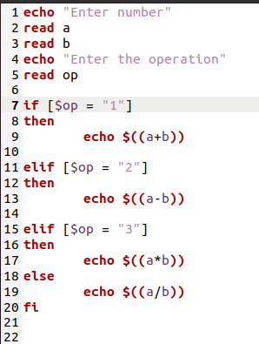
Screenshot:
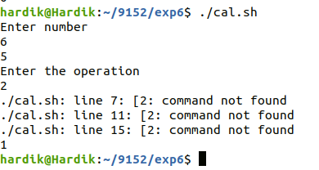

- Implement the program from the following link. Submit the solution on hackerrank
https://www.hackerrank.com/challenges/bash-tutorials---more-on-conditionals/problem?isFullScreen=true
Program:
read X;
read Y;
read Z;
if (($X == $Y)) && (($X == $Z));
then
echo "EQUILATERAL";
elif (($Y == $Z)) || (($X == $Y)) || (($X == $Z));
then
echo "ISOCELES";
else
echo "SCALENE";
fi

Screenshot:
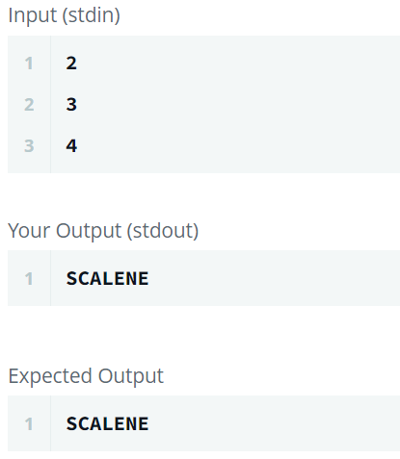
(Also attach the proof, that you have submitted the code on hackerrank)
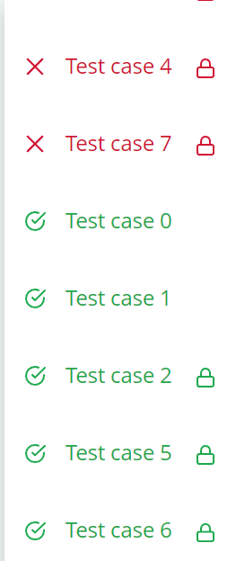

The test cases which have not passed, I checked them by giving manual inputs and it is working.
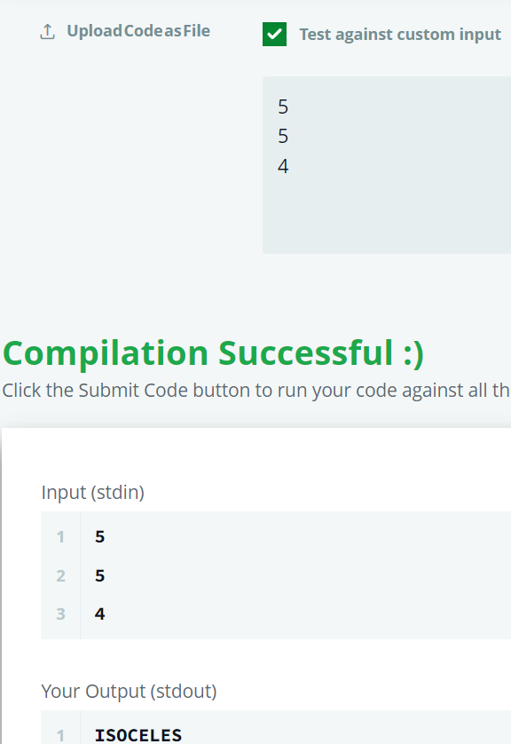

- Implement the program from the following link. Submit the solution on hackerrank
https://www.hackerrank.com/challenges/bash-tutorials---comparing-numbers/problem?isFullScreen=true
Program:
read X; read Y;
if (($X == $Y)); then echo "X is equal to Y"
elif (($X < $Y)); then echo "X is less than Y"
else echo "X is greater than Y"
fi
Screenshot:
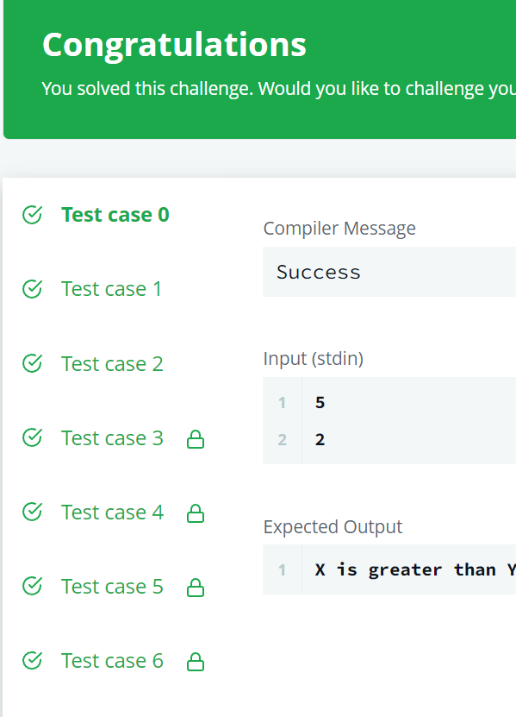

5. | Conclusions & Inferences

Learnt Basics of shell scripting and coded some problems on internet.

6. | Post Lab exercise

- Write a note on awk script

